Fetch

Software Requirements Specification

V0.1

10/5/2024

Alexander Templin
TM Taghon
Ryan Werness
Robert Smisek

Revision History

Date | Description | Author | Comments
10/5/2024 | Version 0.1 | Alexander Templin | First Revision

Document Approval

The following Software Requirements Specification has been accepted and approved by the following:
Signature | Printed Name | Title | Date
 | <Your Name> | Lead Software Eng.
 | A. David McKinnon | Instructor, CptS 322
Table of Contents

Revision History ii
Document Approval ii
1. Introduction 1
1.1 Purpose 1
1.2 Scope 1
1.3 Definitions, Acronyms, and Abbreviations 1
1.4 References 1
1.5 Overview 1
2. General Description 2
2.1 Product Perspective 2
2.2 Product Functions 2
2.3 User Characteristics 2
2.4 General Constraints 2
2.5 Assumptions and Dependencies 2
3. Specific Requirements 2
3.1 External Interface Requirements 3
3.1.1 User Interfaces 3
3
3.2 Functional Requirements 3
3
3.3 Use Cases 3
3.3.1 Use Case #1 3
3
3.4 Classes / Objects 3
3
3.5 Non-Functional Requirements 4
3.5.1 Performance 4
3.5.2 Reliability 4
3.5.3 Availability 4
3.5.4 Security 4
3.5.5 Maintainability 4
3.5.6 Portability 4
3.6 Inverse Requirements 4
3.7 Design Constraints 4
3.8 Logical Database Requirements 4
3.9 Other Requirements 4
4. Analysis Models 4
4.1 Sequence Diagrams 5
4.3 Data Flow Diagrams (DFD) 5
4.2 State-Transition Diagrams (STD) 5
5. Change Management Process 5
A. Appendices 5
A.1 Appendix 1 5
A.2 Appendix 2 5

1. Introduction
This document will cover all requirements and specifications about Fetch.

1.1 Purpose
The purpose of this SRS sheet is to describe the technical requirements that Fetch will adhere to, as well as work as a roadmap for the design phase.

1.2 Scope
Fetch is a dog adoption webapp that will connect users to many different dog shelters and make searching for the right match easy.

Messaging and storing the pet information will be done on servers that the implementer will be responsible for setting up and managing.

Shelters can change their account to a seller account to allow for them to manage listings, message customers and make changes to their account to provide customers with more information.

Fetch will not be responsible for completing the adoption process as that will be left up to the buyer and shelter.

1.3 Definitions, Acronyms, and Abbreviations
Add to this as needed:

This subsection should provide the definitions of all terms, acronyms, and abbreviations required to properly interpret the SRS. This information may be provided by reference to one or more appendixes in the SRS or by reference to other documents.

1.4 References
Add to this as needed:

This subsection should:
(1) Provide a complete list of all documents referenced elsewhere in the SRS, or in a separate, specified document.
(2) Identify each document by title, report number - if applicable - date, and publishing organization.
(3) Specify the sources from which the references can be obtained.
This information may be provided by reference to an appendix or to another document.

1.5 Overview
The rest of the SRS will go over technical requirements as well as several diagrams describing how interactions will go between the users and the system, internal system processes, system and databases and more.

The SRS will be organized into 5 more sections, those being:
2. General Overview of the product and use
3. Specific and technical requirements for the product
4. Control flow and analysis
5. How the product will be changed and managed going forward

2. General Description
Users can browse and overview the website without an account. Users will be able to sort and filter available dogs by many different criteria. After the user makes an account, they will be able to save dogs to lists see later, message shelters with questions about pets and adoption, and go through the adoption process of getting the dog. The specifics of payment and pickup will be left to the buyer and seller.

2.1 Product Perspective
This product will be similar to other shopping websites but this will be more pet friendly and will have a user friendly UI to allow for a better user experience as well as

2.2 Product Functions
The product will allow for a streamline user friendly way to connect adopters and shelters. The main function of the system will be to allow users to login, manage their account, search for pets to adopt, or manage their listings. The system will be responsible for querying the correct messages for both type of users, as well as providing shelters the ability to add, edit, and remove listings, customers the ability to browse and filter available pets. The system will also be responsible for handling the login and authentication process.

2.3 User Characteristics
Users will want to easily pickup where they left off and manage lists of saved available pets. Shelters will want to be able to make changes to their accounts allowing users to see information regarding the shelter. Shelters will also want to easily manage their available pets.

2.4 General Constraints
This product should be easily loadable as well as compatible with many different browsers to allow the product to be easily accessible to all peoples.

2.5 Assumptions and Dependencies
This product will be browser only and should be compatible with any device capable of running said browser.

3. Specific Requirements
The main goal of Fetch will be to easily connect potential adopters with shelters with a friendly UI and easily navigable and understandable design. This section will break down more of the technical requirements for Fetch.

3.1 External Interface Requirements

3.1.1 User Interfaces
Below is an rough example of what the main landing page should look like. The final product will be very different and design decisions should be based off of the example but do not need to follow it.
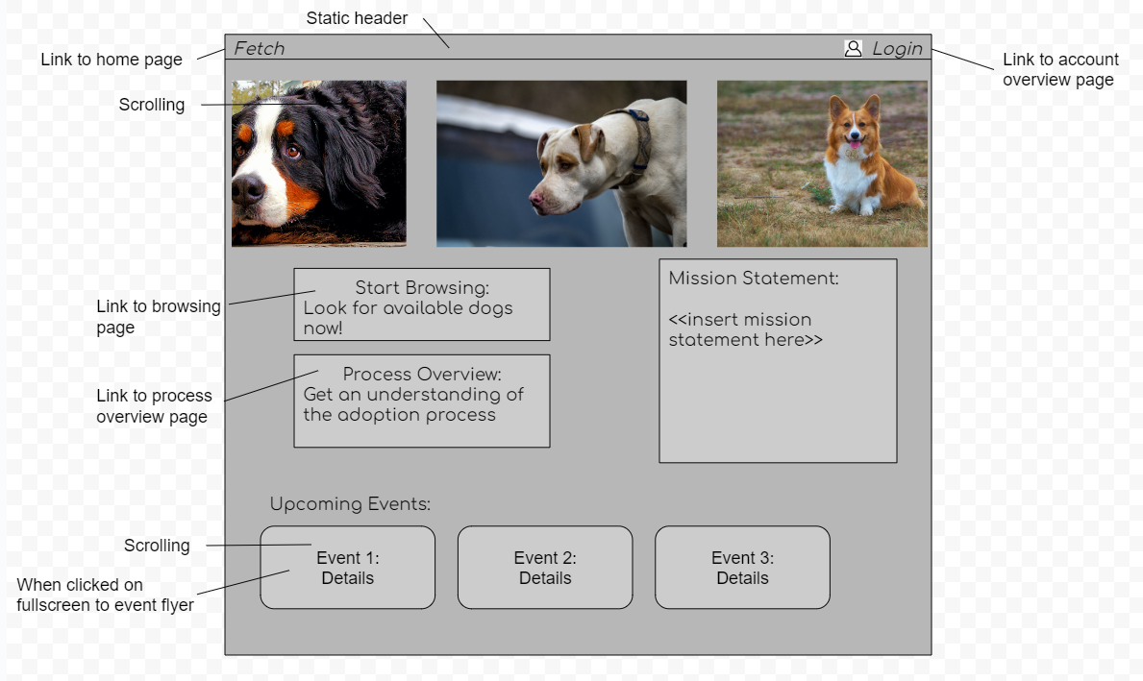

Below is another example, this one of the sign up/ login page.

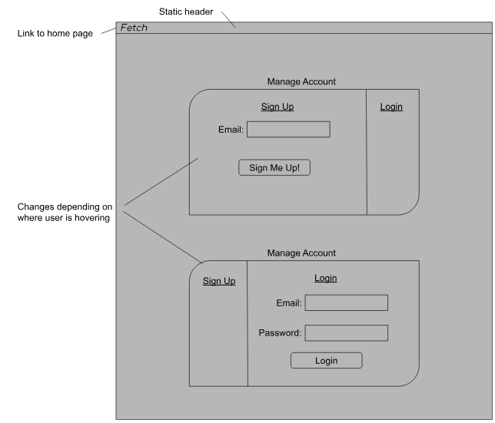

3.2 Functional Requirements
Identifier | Requirement | Use Case
REQ 1 | Register a new Customer  Any person can register customer account  The user must provide an email address, the system will then send that email a link to verify, this will then redirect the user to finish setting up their account  The account information will consist of:  Things with * are required  - Main email*  - Recovery email  - Phone number  - Full Name*  - Profile picture  - Address  - Password* (must be entered twice and follow the requirements stated in REQ 2)  It will be clear to the user that this information can be edited later as well.  If the user fails to fill all required fields their will be an error message: “<insert field here> must be entered.” | UC - 1
REQ 2 | Login  The system must allow registered customers to log in to their accounts by entering their username and password.  The system must allow customers to reset their password by clicking "I forgot my password" and receiving a link to their verified email address.  Username should include:  - The username must be at least six characters long.  - Use letters (a-z), letters (A-Z), numbers (0-9), and underscore( _) or ( @) characters.  The password should include:  - The password must be at least ten characters long.  - Use the mix of letters (a-z), letters (A-Z), numbers (0-9), and special characters.  - The password must contain at least 1 special character, 1 uppercase letter, 1 lowercase letter, and 1 number.  If the registered customers cannot provide a valid name and password, display the error message: “Invalid username or password.” | UC - 2
REQ 3 | Register a shelter account  The user must provide an email address, the system will then send that email a link to verify, this will then redirect the user to finish setting up their account  The account information will consist of:  Things with * are required  - Main email *  - Recovery email *  - Phone number *  - Business Name*  - Display Name*  - Profile picture *  - Address *  - Password * (must be entered twice and follow the requirements stated in REQ 2)  It will be clear to the user that this information can be edited later as well.  If the user fails to fill all required fields their will be an error message: “<insert field here> must be entered.”  After all the information is submitted it will create a request that an admin of the system will have to review and verify the information with the shelter to finish the creation of the account. The user will see a screen explaining that the shelter must be verified through Fetch, it will provide an email and a phone number for getting in touch with a Fetch administrator. They will also get emails stating the status of their account, the possible stages are:  - Review Submitted  - Under Review  - Declined  - Accepted
REQ 4 | Browse  Anyone can browse available pets regardless of account type or if even logged in. The user will be able to search based on:  - Name  - Breed  - Shelter  The user will also be able to sort by:  - Date added (default)  - Breed  - Age  - Shelter  - Range (must give a location and distance)
REQ 5 | Create and mange lists  Registered users will be able to create, rename, edit, and delete lists that they can view from their account page. They will be able to add current listings to whatever list they chose or to add it to a new list. Users will be an email from the system if the status of one of their pets in a list is changed, the pet will remain in the list unless the listing is removed from the system or the user removes it.
REQ 6 | Create, edit, remove listing  Registered shelters will be able to see an overview of all their current listings from their account page. Their will be a button to add a new listing as well as all current listings will have edit and remove buttons on them.  Listings must contain:  - Name  - Breed  - Age  - Location (will be shelters location by default)  - Description  - Fees
REQ 7 | View Profiles  Any user can click on another user’s icon and view their profile. If the target user is a shelter, then it will display all the relevant information as well as the shelters current listings (these can be sort through just like REQ 4). If the target user is a Customer, it will display their relevant information. For all users there will also be a message button which will redirect the user:  - If the current user is signed in:  - If the two users have existing messages it will bring the user to those messages  - If the two users don’t have existing messages it will prompt the user to send the target user a new message  - If the current user is not signed in it will redirect them to the sign in/ login page
REQ 8 | Profile Pages  Shelters will be able to edit their description as well as add pictures and manage listings (REQ 6). All register customers will be able to edit their profile page and select what information they would like to display.
REQ 9 | Messages  All users will have a messages button in the top right of the header, this is redirect to a page containing all messages. If the user is signed in it will display the name of the other user, their profile picture, and the last message sent/received. However, if the user is not signed in it will redirect them to the sign in/login page.

3.3 Use Cases
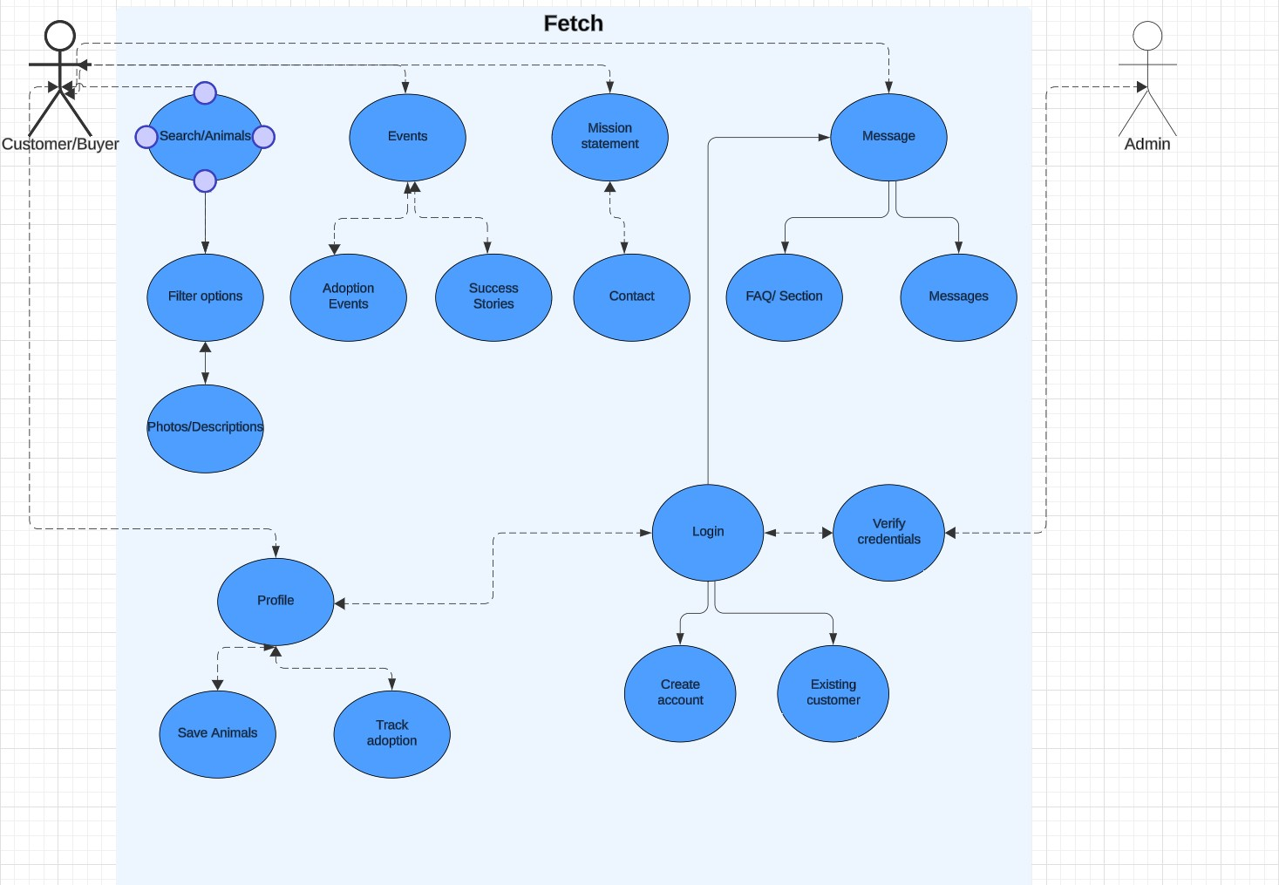

3.4 Classes / Objects
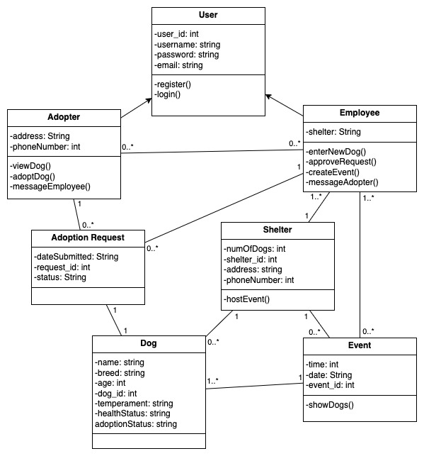

3.5 Non-Functional Requirements
Non-functional requirements may exist for the following attributes. Often these requirements must be achieved at a system-wide level rather than at a unit level. State the requirements in the following sections in measurable terms (e.g., 95% of transaction shall be processed in less than a second, system downtime may not exceed 1 minute per day, > 30 day MTBF value, etc).

3.5.1 Performance

3.5.2 Reliability

3.5.3 Availability

3.5.4 Security

3.5.5 Maintainability

3.5.6 Portability

3.6 Inverse Requirements
State any *useful* inverse requirements.

3.7 Design Constraints
Specify design constrains imposed by other standards, company policies, hardware limitation, etc. that will impact this software project.

3.8 Logical Database Requirements
Will a database be used? If so, what logical requirements exist for data formats, storage capabilities, data retention, data integrity, etc.

3.9 Other Requirements
Catchall section for any additional requirements.

4. Analysis Models
List all analysis models used in developing specific requirements previously given in this SRS. Each model should include an introduction and a narrative description. Furthermore, each model should be traceable the SRS’s requirements.

4.1 Sequence Diagrams

4.3 Data Flow Diagrams (DFD) or Activity diagrams
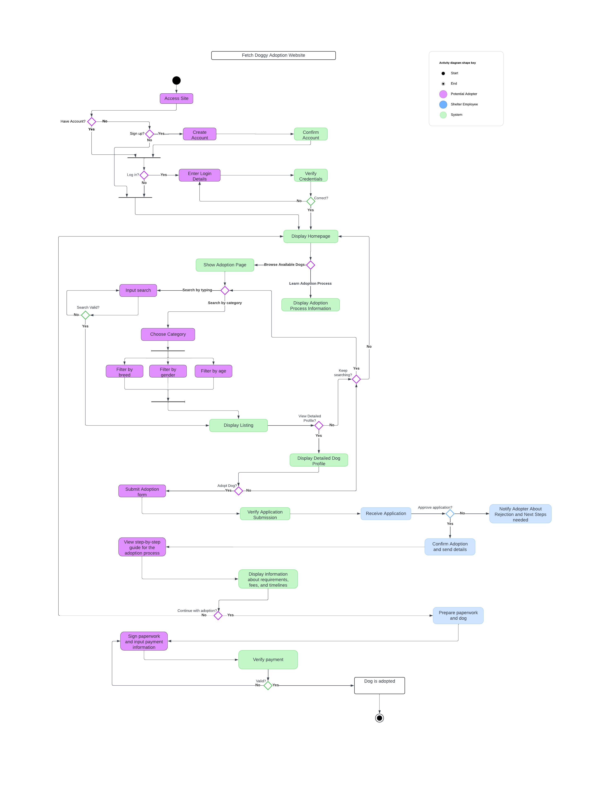
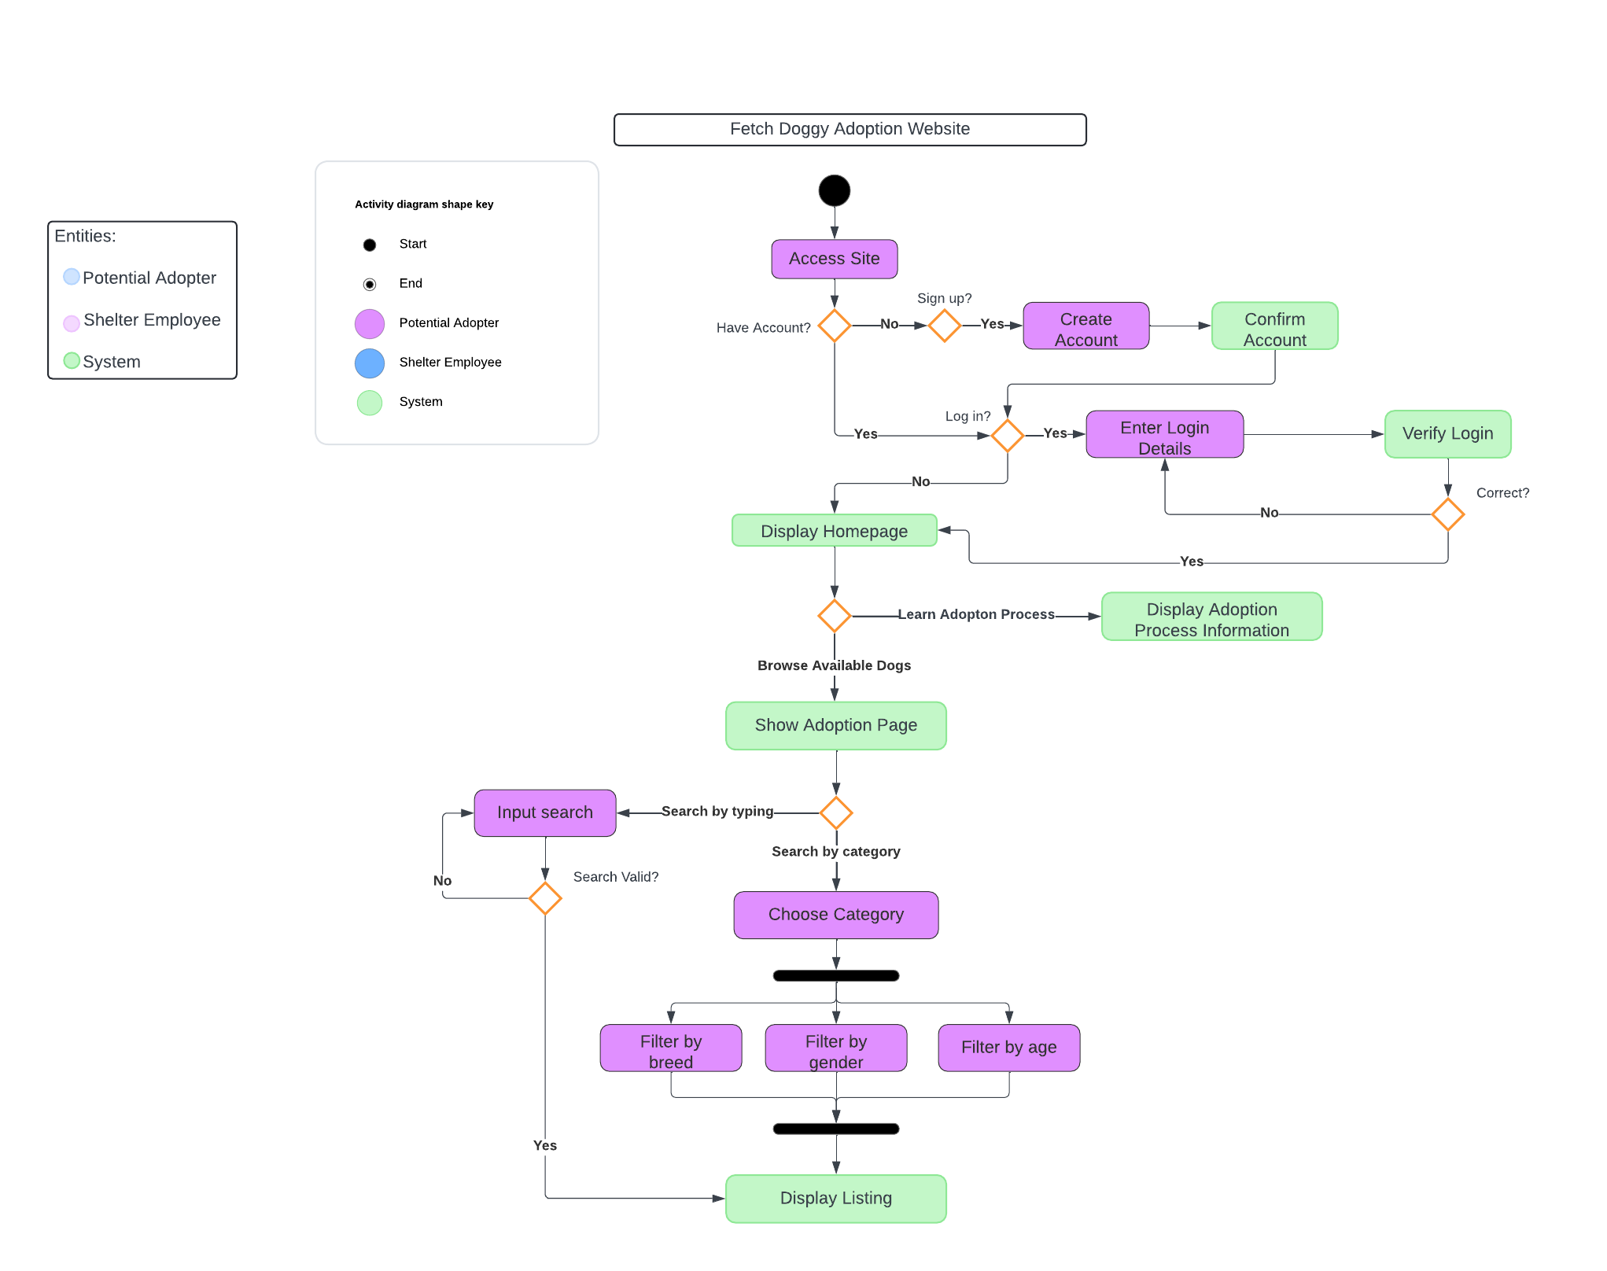

4.2 State-Transition Diagrams (STD)

5. Change Management Process
Identify and describe the process that will be used to update the SRS, as needed, when project scope or requirements change. Who can submit changes and by what means, and how will these changes be approved.

A. Appendices
Appendices may be used to provide additional (and hopefully helpful) information. If present, the SRS should explicitly state whether the information contained within an appendix is to be considered as a part of the SRS’s overall set of requirements.

Example Appendices could include (initial) conceptual documents for the software project, marketing materials, minutes of meetings with the customer(s), etc.

A.1 Appendix 1

A.2 Appendix 2

